

Data Technician

Name: Rebecca Osewa
Course Date: 03/12/2025
Table of contents
Day 3: Task 1 3
Day 3: Task 2 4
Dataset: 4
Step 1: Create a Pivot Table 4
Step 2: Use the SWITCH Function 4
Submission: 5
Day 3: Task 3 6
Course Notes 7
Addition Resources 8
Addition formation 9

Day 3: Task 1

Please download the dataset ‘Day_3_Task_1_Bike_Sales_Pivot_Lab.xlsx’ from here.

The lab instructions can be found here. Do not worry if you do not complete the lab, just working with data and playing with the pivot table will be good experience.

Please paste your final pivot table below and complete the reflection questions:

Print screen 1
In which markets does Germany have customers? | 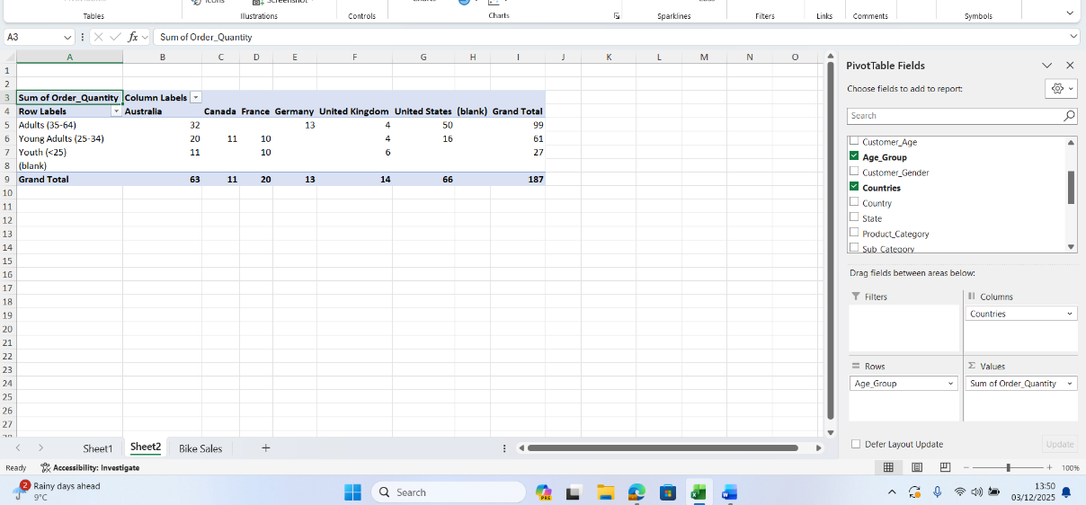
What country has sales in all markets? | 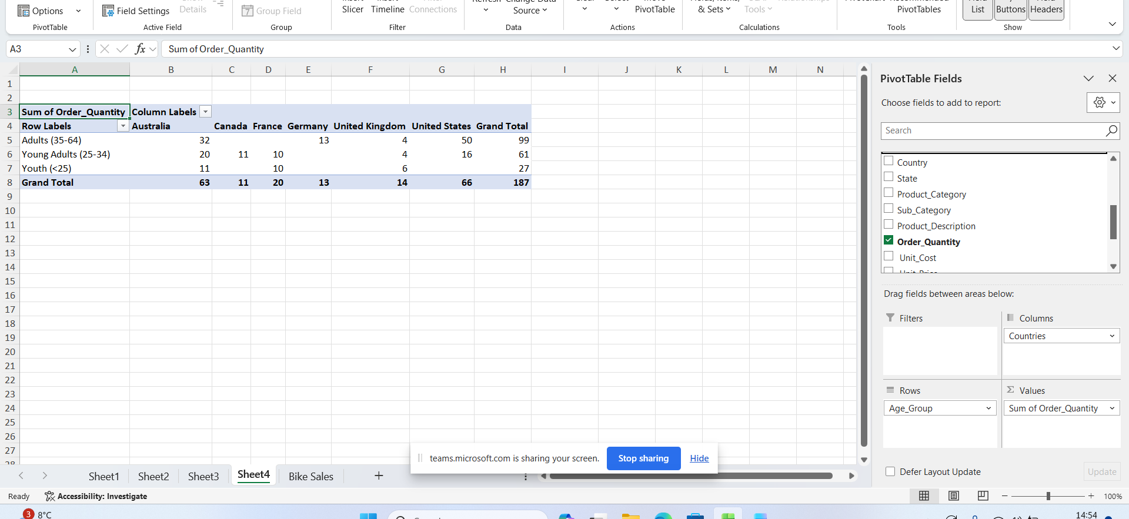
What are the most profitable markets by country, age group, and gender? | 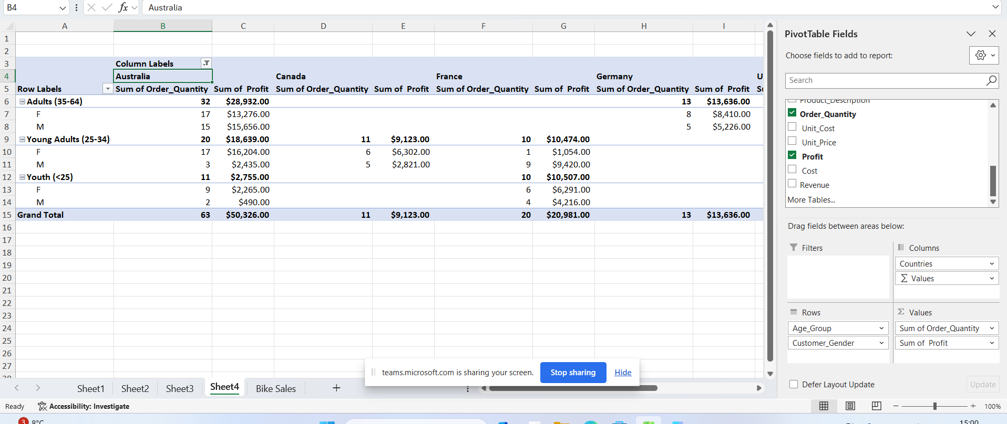
Any other findings?

Day 3: Task 2
The dataset below tracks the sales performance of different products in various counties in England. Please paste the dataset into a blank Excel workbook. Your task is to:
- Create a Pivot Table to summarise the data by county and product.
- Use the SWITCH function to categorise products based on their sales volume.

Dataset:
County | Product | Sales Volume
Yorkshire | Laptops | 500
Yorkshire | Smartphones | 200
Cornwall | Laptops | 700
Cornwall | Printers | 400
Lancashire | Smartphones | 150
Lancashire | Laptops | 600
Essex | Printers | 800
Essex | Smartphones | 300
Durham | Laptops | 250
Durham | Printers | 300
Greater Manchester | Smartphones | 600
Greater Manchester | Laptops | 400

Step 1: Create a Pivot Table
- Select the dataset (columns A to C).
- Insert a Pivot Table to summarise the data by County in the rows and Products in the columns. Use Sales Volume as the value to be summarised.

Step 2: Use the SWITCH Function
In a new column next to your data, use the SWITCH function to categorise products based on Sales Volume as follows:
  - For sales greater than 600: "High"
  - For sales between 300 and 600: "Medium"
  - For sales less than 300: "Low"
SWITCH Function Example:
=SWITCH(TRUE, C2 > 600, "High", C2 >= 300, "Medium", "Low")
- Apply this formula to each row, and check if the products are categorised correctly.

Submission:
- A completed Pivot Table summarising sales by county and product.
- A new column in the dataset categorising products by sales volume using the SWITCH function.
  - Please paste your completed work below

Print screen 1 | 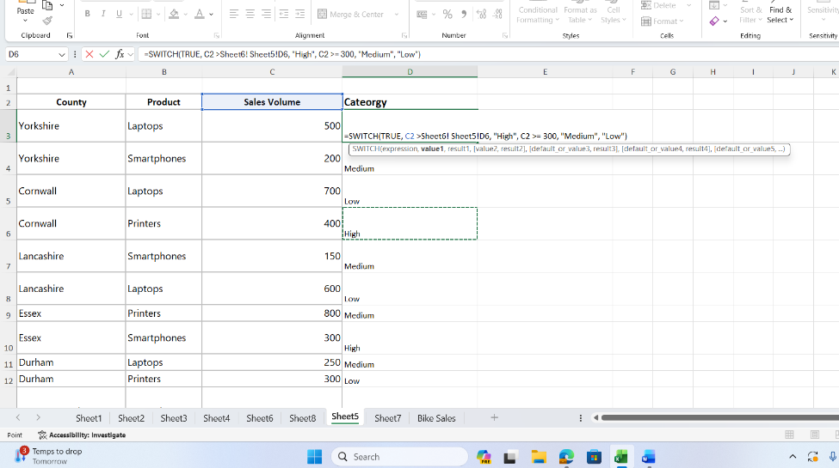

Day 3: Task 3

Please download the dataset ‘Day_3_Task_3_Bike_Sales_Visualisations_Lab.xlsx’ from here.

The lab instructions can be found here. Do not worry if you do not complete the lab, just working with data and playing with the charts will be good experience.

Please paste your results below:

Print screen 1 | 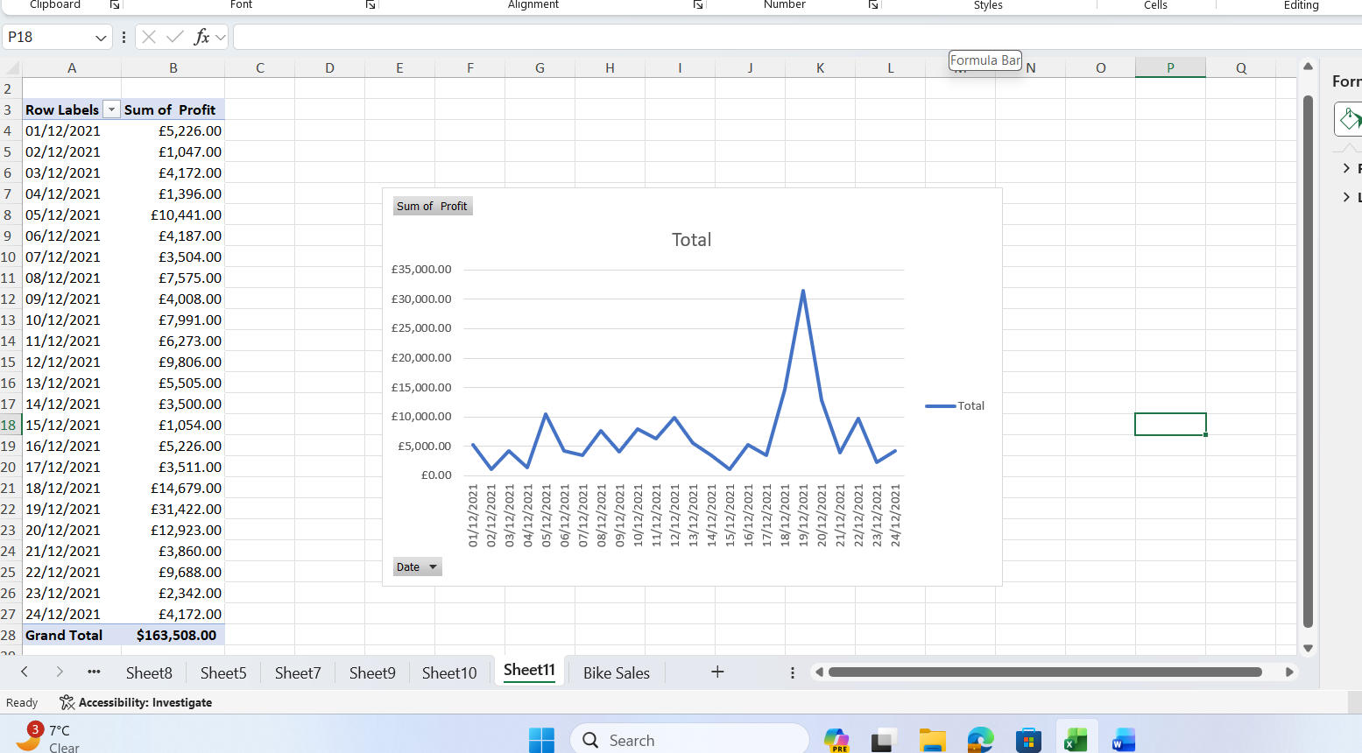  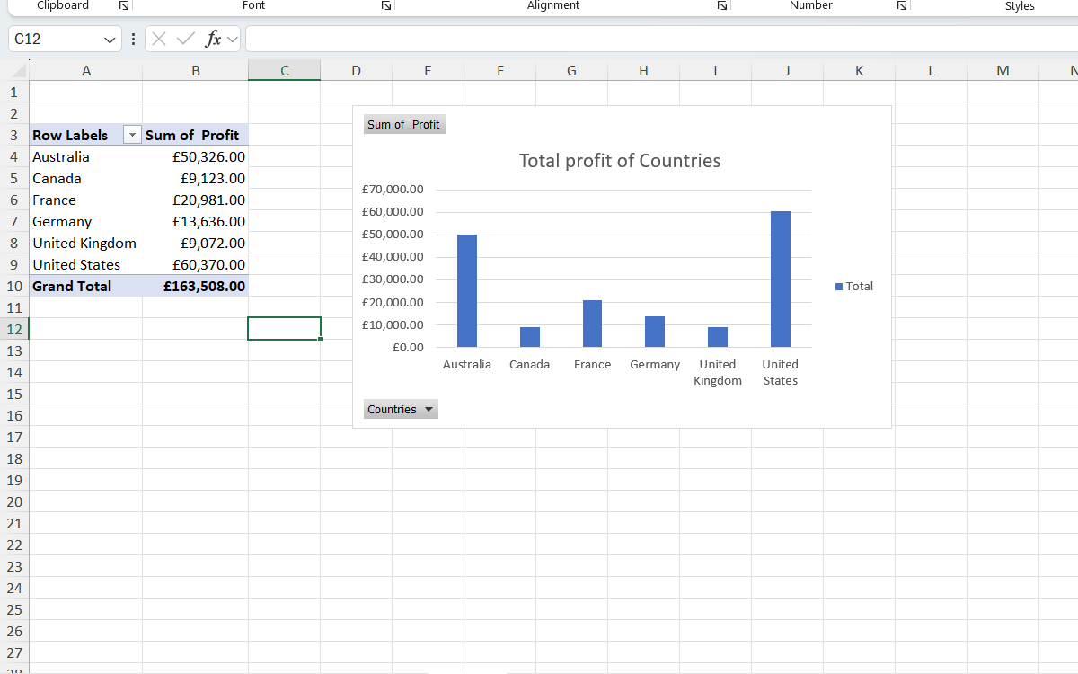

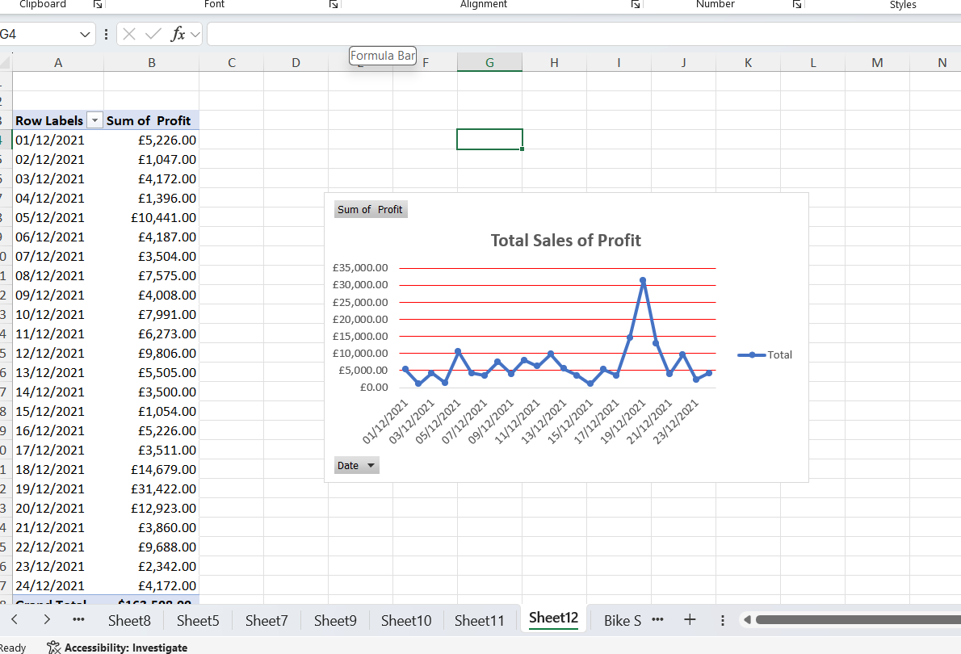

Course Notes
It is recommended to take notes from the course, use the space below to do so, or use the revision guide shared with the class:
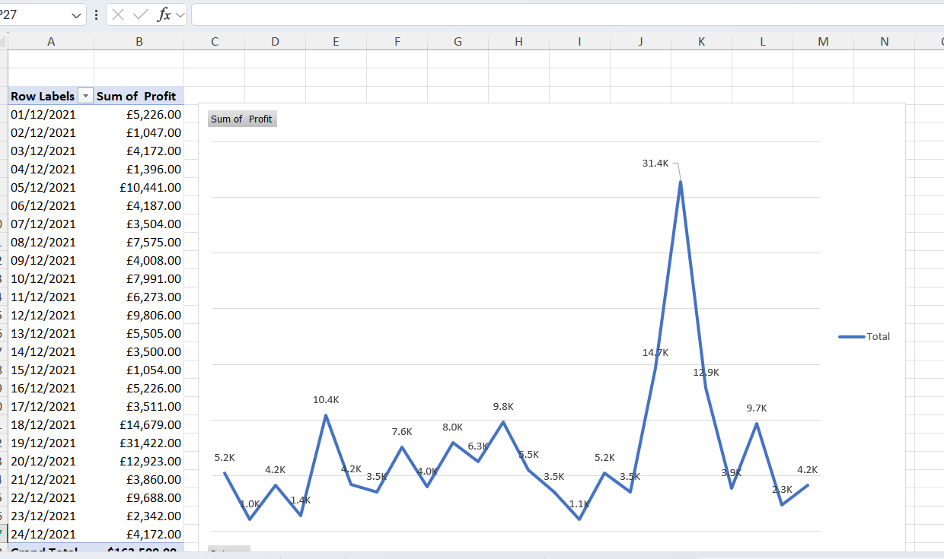

Addition Resources
Please explore the additional resources to support your learning.
- Introduction to Data Analytics Essentials
This data analytics essentials course teaches you the fundamental tools of a data analyst. You will learn to transform, organize, and visualize data with spreadsheet tools such as Excel.

- Excel Formulas and Functions Tutorial
Formulas can be used to perform simple math using +,-,*, or / to add, subtract, multiply or divide. Excel also comes built-in with over 300 functions that can be used to perform complex math, lookup values, work with text, and much more. This section will cover creating simple formulas, cell references, strings of text, and keyboard shortcuts.

- Excel Exercises Dashboard
Our bite-sized, interactive lessons make Excel skills easy to learn and remember.

- 100+ Excel Interview Questions & Answers To Make You Job Ready
This guide can also be used by interviewers who want to gauge the Excel skill of the candidates in the interview.

- ❎ How to use Excel - YouTube
In these step-by-step tutorials, learn how to use Microsoft Excel. Find out how to get started with MS Excel in under 10 minutes. Learn about Pivot Tables, formulas and functions, vlookup, shortcuts. Also, find out about the latest new features and the top tips and tricks.

- Use Excel skills (Filter, Sort, Conditional Formatting, Functions, VLOOKUP, Pivot Tables, Pivot Charts, and Slicers) to analyse global sales data and uncover key insights.
- Find exercises here Global Superstore Data Challenge.docx
- Open dataset global_superstore_2016.xlsx in Excel online and create an online copy.

Addition formation
We have included a range of additional links to further resources and information that you may find useful, these can be found within your revision guide.

END OF WORKBOOK

Please check through your work thoroughly before submitting and update the table of contents if required.

Please send your completed work booklet to your trainer by submitting in MS Teams Assignment page.

